|  |  |
| --- | --- |
| **BOOSTER PUMP** | **UNIT: PUM003** |

|  |  |
| --- | --- |
| PERFORMANCE | |
| Maximum Flow Rate | 1800 USGPM (6.81 m3/min) |
| Maximum Head | 220 ft |
| Minimum NPSH | 7 ft |

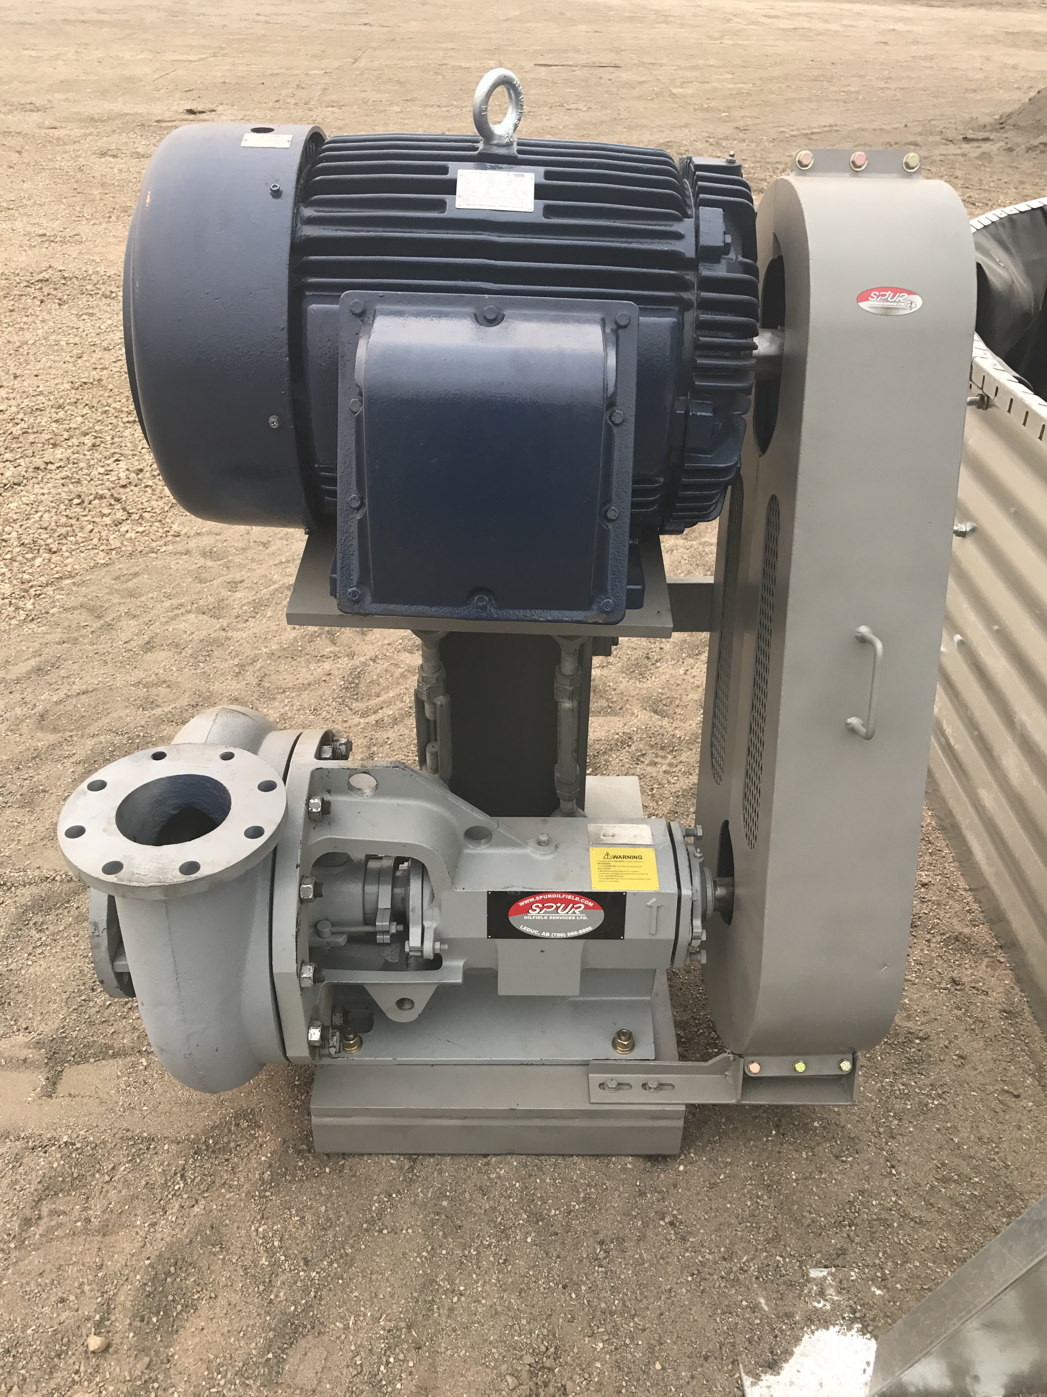

|  |
| --- |
| DRIVE |
| Make | Teco Westinghouse |
| Model | AEHHXU |
| Horse Power | 75 HP |
| RPM | 1780 RPM |
| Volts | 230/460 V |
| Amps | 167/83.5 |
| Hertz | 60 Hz |
| VFD Compatible | Yes |

|  |
| --- |
| PUMP |
| Model | Spur Oilfield |
| Model | S654HIS |
| Impeller Size | 14” (355.6 mm) |
| Casing Rating | 275 psi (1,896 kPa) |

|  |
| --- |
| PIPING CONNECTIONS |
| Inlet | 6” (168.3 mm) |
| Connection | CL150 RF |
| Outlet | 5” (141.3 mm) |
| Connection | CL150 RF |

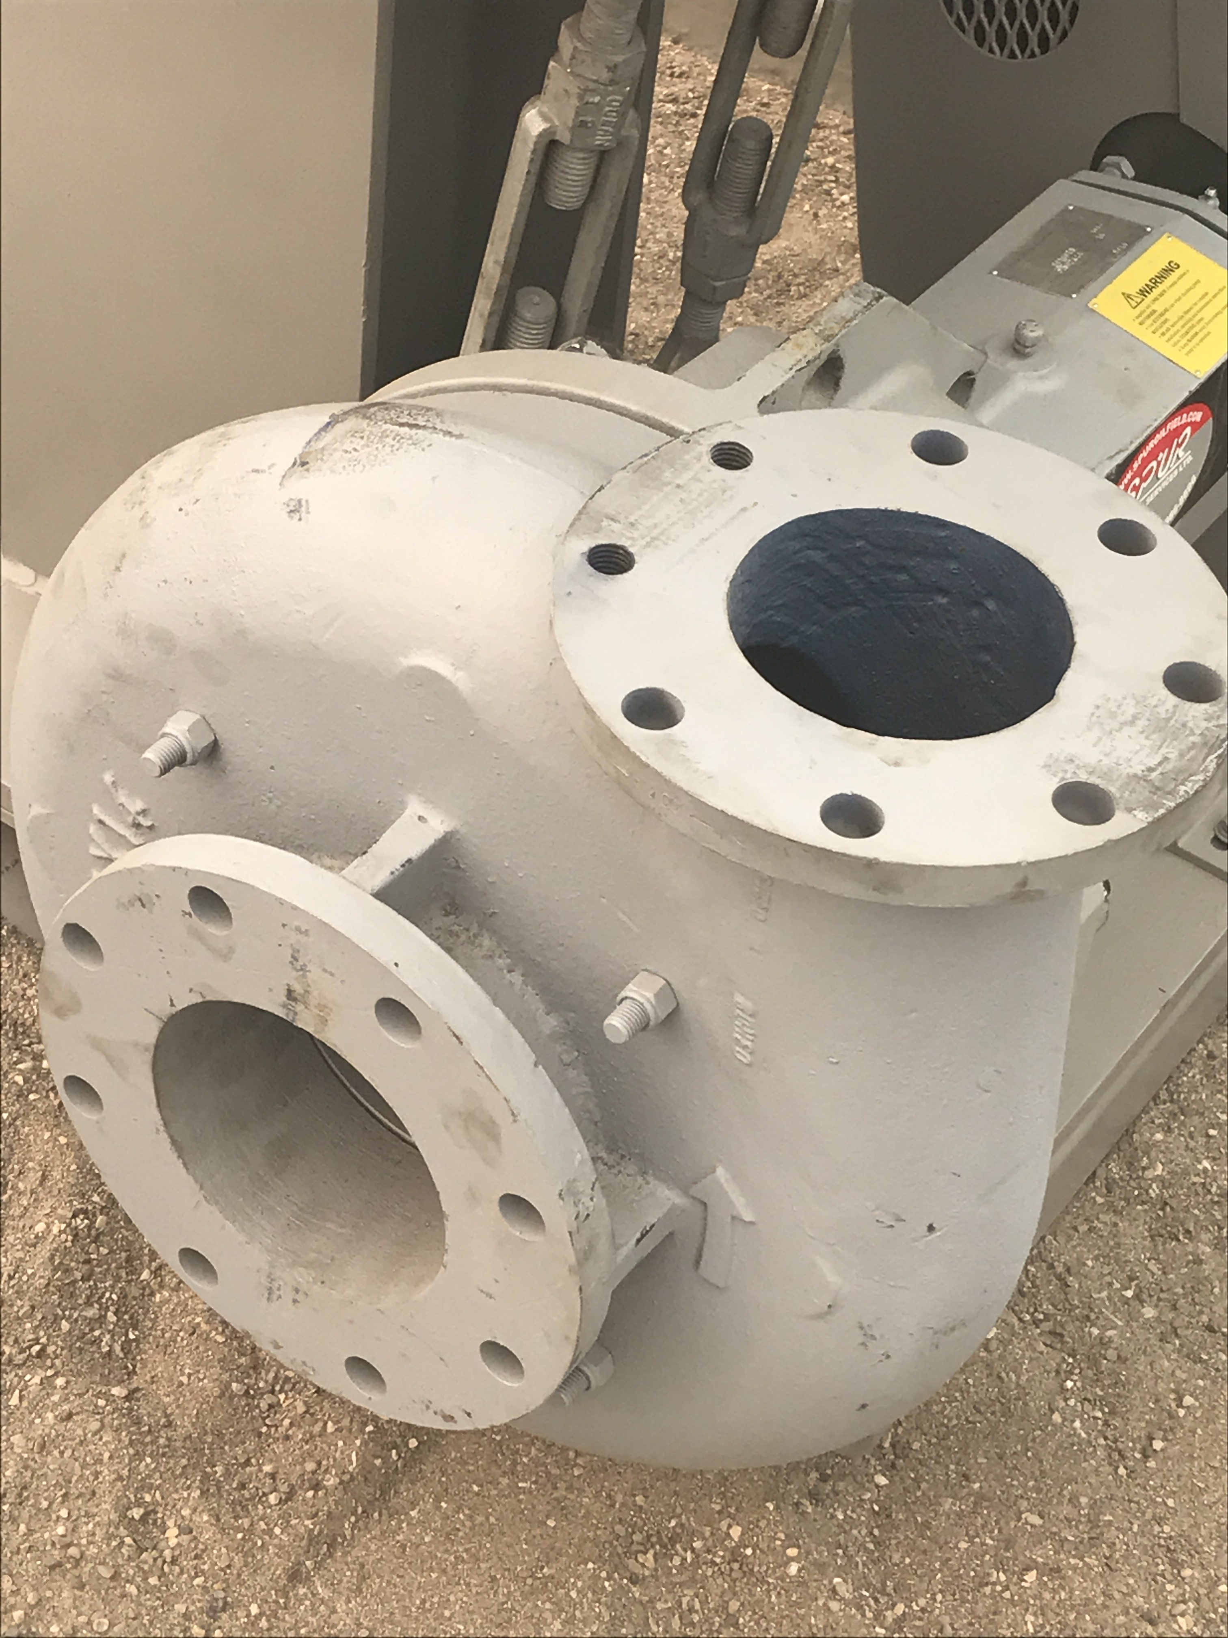

|  |
| --- |
| SHIPPING DIMENSIONS |
| Width | 55” (1.39 m) |
| Length | 56” (1.42 m) |
| Height | 60” (1.52 m) |
| Weight Estimate | 1643 lbs (747 kg) |

|  |
| --- |
| POWER REQUIREMENTS |
| Motor | 66.5 kW |
| Voltage Input | 460V |
| Phase | 3Ø |

**Approximate Power Requirements**

|  |  |
| --- | --- |
| CERTIFICATION | |
| Drive | Class I Div 1, Groups D; Class II Div 1, Groups E,F, G Class I Zone 1, Groups IIA Class II Div 1 Groups E,F,G |

**PUMP CURVE**

